PROJECT OBJECTS\PRJ and FWA Direct Assignment Changes

|  |  |  |  |
| --- | --- | --- | --- |
| **Revision** | **Date** | **Description** | **Author** |
| 01 | 17/07/2023 | PRJ and FWA Direct Assignment Changes | G. Riccardi |

© 2015 Project Objects Srl

Via Pellettier, 4 – 20900 Monza (MB) - Italy

Tel. +39 039 - FAX +353-46-9282099

Table of Contents

1. PRJ and FWA Direct Assignment Changes 3

2. PRJ Direct Assignment Workflow Changes 3

3. PRJ Direct Assignment Dropdown Changes 3

4. FWA Direct Assignment Dropdown Changes 3

5. FWA Direct Assignment Workflow Changes 4

6. FWA Direct Assignment Form Changes 4

7. FWA Direct Assignment Opentext Integration Changes 6

# PRJ and FWA Direct Assignment Changes

* **Implementation logic**

It is required by Enel to modify PRJ and FWA Direct Assignment Form

# PRJ Direct Assignment Workflow Changes

* **Implementation logic**

It is required by Enel to modify PRJ Direct Assignment Workflow

* **General implementation requisite**

When Release from Step 2 to Step 3 Ownership and email notification should go only to the same User Originator that originated the Object PRJ Direct Assignment.

# PRJ Direct Assignment Dropdown Changes – Already done

* **Implementation logic**

It is required by Enel to modify PRJ Direct Assignment Dropdown

* **General implementation requisite**

Field "Requesting Company" should Point to Table of Enel Entity SPV

# FWA Direct Assignment Dropdown Changes - Already done

* **Implementation logic**

It is required by Enel to modify FWA Direct Assignment Dropdown

* **General implementation requisite**

Field "Requesting Company" should Point to Table of Enel Entity SPV

# FWA Direct Assignment Workflow Changes (Will be DOne By Guido/Danilo - Already done

* **Implementation logic**

It is required by Enel to modify FWA Direct Assignment Workflow

* **General implementation requisite**

at Step "Awaiting Validation" it is required to add the Possibility to activate the Review Process

# FWA Direct Assignment Form Changes

* **Implementation logic**

It is required by Enel to modify FWA Direct Assignment Form

* **General implementation requisite**

Rename Section FWA DIRECT ASSIGNMENT SECTION B in FWA DIRECT ASSIGNMENT SECTION C

Create a Section FWA DIRECT ASSIGNMENT SECTION B and moving form Section A the PR Releated fields (Section B editable at step 2)

Rename **Estimated Amount** in **PR** **Amount** (also the €)

Add in Section A Field Estimated Amount, Currency and Estimated Amount (€) converted with "Opening Date "

Please see image Below for all the details:

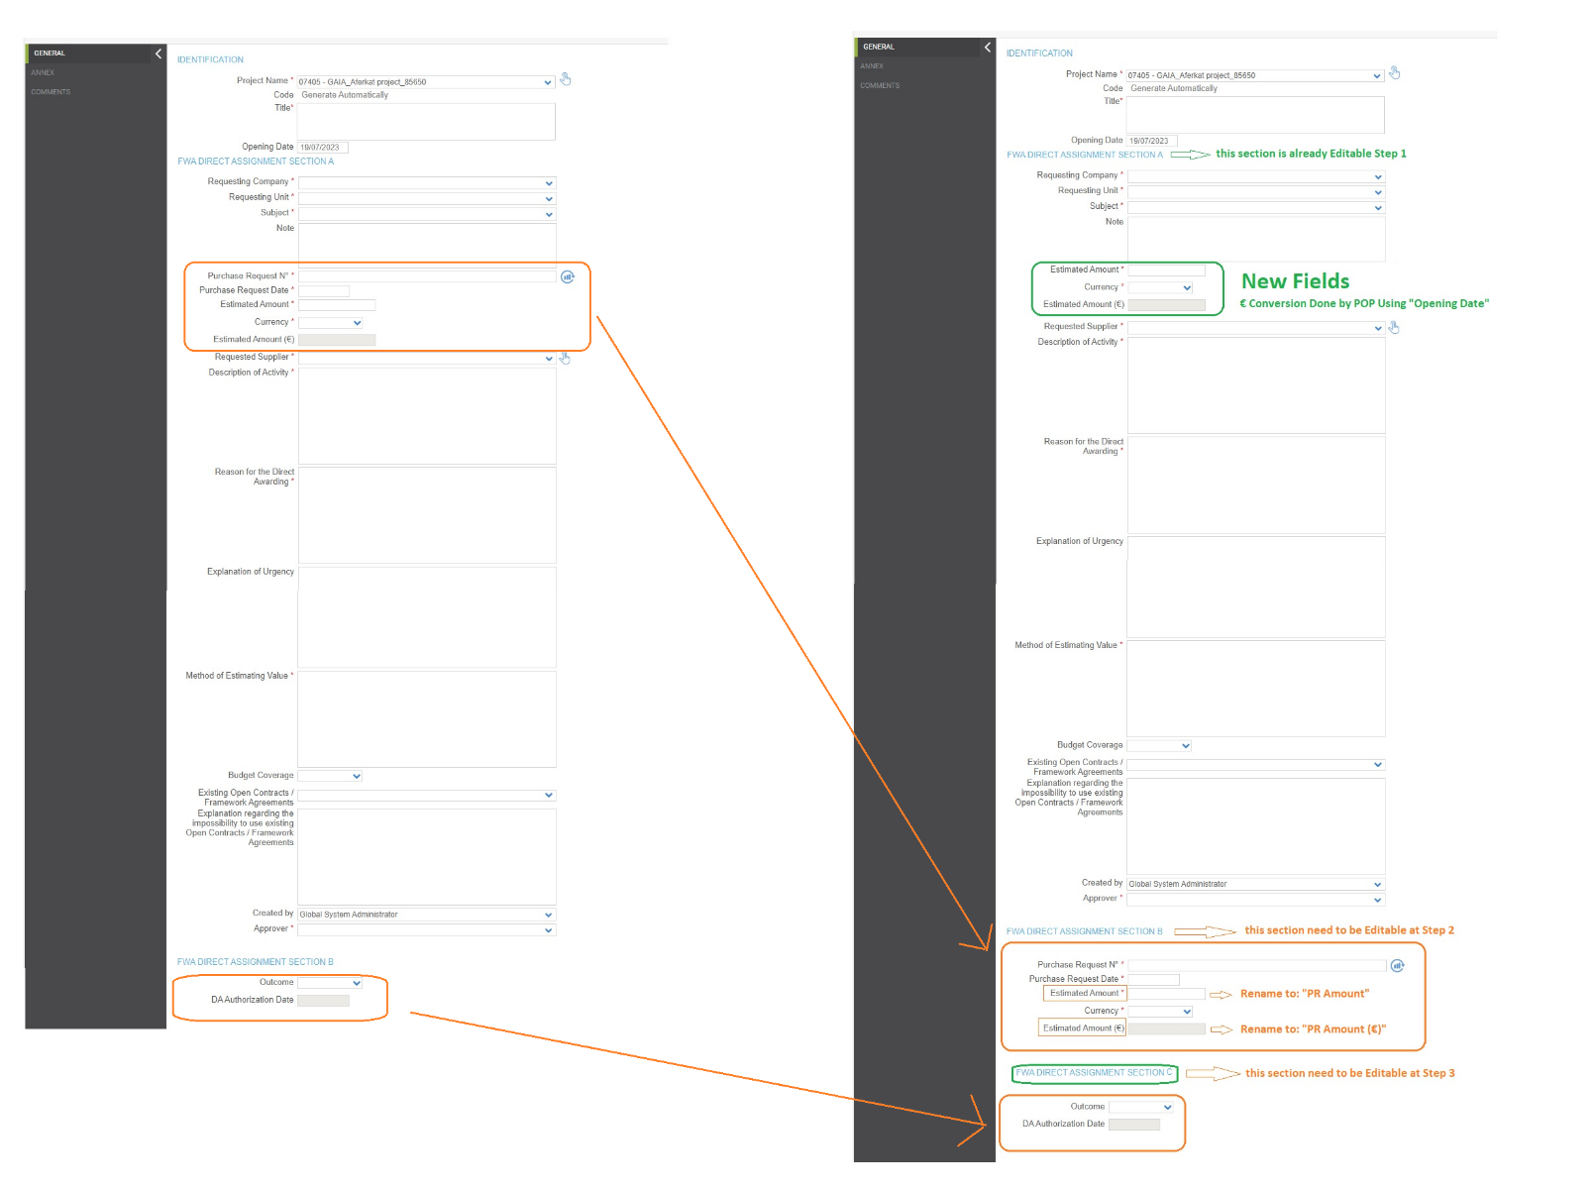

**Those changes on Field Names and new Fields should be reflected in FWA Direct Assignments Dashboard Data Source.  
  
PDF should keep Exposing same Fields as before (PR Related fields with new name)  
the new fields (Estimated Amount, Currency, and Estimated Amount (€)) to be created in this development should not be in PDF**.

# FWA Direct Assignment Opentext Integration Changes

* **Implementation logic**

It is required by Enel to modify FWA Direct Assignment Opentext Integration

* **General implementation requisite**

At the moment we create the Folder adding Metadata, but some Metadata will be available now only at step 2 of the WF, therefore we will keep all the process of folder creation etc. when the form is created by the user, as it is now, but it is required to add another function, to Update Metadata (using Metadata API for Update) when User release from Step 2.

**this is the link to access to the API to update the metadata values.**

<https://gpg-platform-frontend-dev.enelint.global/devportal/apis/a9f31240-a717-44a2-ae76-f5c1022de7a5/overview>

PLEASE CONSIDER the beginning of the link to API that it should be same as we are using for our development (POP DEV to Opentext QA and POP PROD to Opentext PROD)

The 3 fields that will be updated are the one indicated in the table Below. The 3 Fields on the right related to Purchase Request.  
Please note that as now the last field was called **Estimated Amount (€)** and now we should pass the value of the field renamed in requirement above from **Estimated Amount (€)** to **PR Amount (€)**

**All other logics implemented must be the same as is now**

